Final Report
UMGC CMSC 495 Section 6384
Arora, Neil
Pierce, Holden
Stigall, Michael
Thompson, Kosie

Table of Contents

Introduction
The team came together to build a classic arcade breakout game. As a group it was agreed that development of this simple, yet timeless arcade game, would be complex enough to be interesting but simple enough to be contained within the time restrictions of an eight-week class. The goal of the Minimum Viable Product (MVP) was to provide an implementation which contained all base features: core gameplay systems, modular structure, state management, unit test coverage and full documentation.
The project was built using Python and Pygame within a structured and version-controlled environment, ensuring consistency across development machines. The team focused on performance stability, clean architectural separation between gameplay entities, managers, and UI components. Additionally, comprehensive automated testing was implemented using pytest from the beginning to help prevent regression and provide a check for reliability as the code base evolved.
By emphasizing maintainability, scalability, and correctness, the team was able to build a fully stable MVP and add stretch features, while maintaining software development best practices. The team incorporated a structured design, collaborative workflows, and real-world testing strategy.

1 Process Overview
The project followed an iterative development process structured around one-week sprint cycles. Each sprint included planning, implementation, integration, testing, and review phases. Git-based version control ensured traceability of changes and facilitated parallel development.
Development artifacts included:
- Requirements specification document
- Architectural design outline
- Level configuration files
- Automated test suite using pytest
- Sprint milestone schedule
- User guide documentation
Responsibilities were distributed according to system components while maintaining cross-review for integration:
- Ball physics and gameplay mechanics – Holden Pierce
- Collision and level management – Neil Arora
- Input handling and state transitions – Michael Stigall
- Score management and progression logic – Kosie Thompson
- Documentation, validation, and integration – All members
Although components were individually owned, integration checkpoints required each member to understand the entire system. During internal reviews, members presented their modules and answered cross-functional questions, ensuring shared system knowledge.

2 Requirements Specification
Architectural Overview
The system is structured around three primary layers:
- Gameplay Entities – Ball, Paddle, Block
- Manager Components – Collision Manager, Level Manager, Input Manager, Score Manager
- State Controller and Main Loop
The main loop executes in deterministic order: process input, update physics, resolve collisions, update score/state, render graphics. This consistent sequencing reduces unpredictable behavior and simplifies debugging.
Centralized Collision Management
Embedding collision logic directly into entities would have increased coupling and reduced testability. Centralizing collision logic allowed independent unit testing of interaction rules and simplified future modification of physics behavior.
JSON-Based Level Configuration
External configuration improves extensibility and separates content from logic. This design enables future developers to add levels without modifying gameplay code.
State-Driven UI
Explicit state management prevents accidental state overlap and ensures predictable transitions.

3 Project Design
The system architecture can be described by breaking into three layers: Entity, Manager, and Game state. The modular structure ensures that gameplay logic remains independent from rendering and input systems.
Entity Layer
- Ball: Handles velocity, position updates, and direction normalization.
- Paddle: Manages player movement and screen boundaries.
- Block: Contains HP, score value, and collision response logic.
Manager Layer
- Collision Manager: Centralized collision detection and response.
- Input Manager: Processes keyboard events and state transitions.
- Score Manager: Tracks score, lives, level progression.
- Level Manager: Loads and validates level files.
State Management
The game transitions between:
- Start Screen
- Level Selection
- Playing
- Level Complete
- Game Over

4 Project Evaluation

4.1 Testing Strategy
The testing strategy incorporates multiple types of tests, smoke tests, automated unit tests, and user tests. The smoke test is utilized to very quickly check if the basic functionality is working and will only fire if there is a critical issue. Whereas the unit tests will only be run when the appropriate command is entered: python -m pytest -q tests.
For user testing the team designed a series of tests to include basic gameplay: does the ball bounce reasonably, does each screen transition to the next seamlessly, does the score increase, does life decrease as expected, and does level transitions work as expected. In the test results section each element of the unit tests and user testing will be fully documented.

4.2 Test Plan and Results

Unit Tests
The unit tests focus on the main gameplay behaviors which are most important to the Breakout game.
Ball (direction, movement, hitbox)
- Confirms the ball correctly scales the direction values (vx, vy) into a consistent direction.
- Confirms the ball does not get stuck when initialized with no direction (vx=0, vy=0).
- Confirms update(dt) moves the ball the correct distance over time.
- Confirms rect() returns the correct collision box around the ball.
Paddle (movement, boundaries, hitbox)
- Confirms paddle movement updates x correctly when moving left/right.
- Confirms the paddle cannot move off-screen (clamps at the left and right edges).
- Confirms rect() returns the correct collision box around the paddle.
Block (init, hit logic, hitbox)
- Confirms blocks initialize with correct position/size and settings (hp, score, color, etc.).
- Confirms rect() returns the correct collision box.
- Confirms hit() reduces HP correctly and reports when the block is destroyed.
Level (map loading, validation, conversion)
- Confirms Level.from_file() loads a JSON level file correctly (width, height, tile size, and blocks).
- Confirms invalid level data is handled correctly (ex: negative grid coordinates, invalid JSON, missing file).
- Confirms all level JSON files in the levels/asset’s directory can be loaded and converted into valid Block objects.
Collision Manager
- Wall collisions, cause ball to reverse direction and is constrained when it hits the edges.
- Paddle interaction, only downward-moving balls will trigger a bounce; bounce updates velocity and will position the ball above the paddle.
- Block collisions, detect and handle ball and block overlap, flips velocity appropriately, removes destroyed blocks and reports the score value.
- Void check, returns True when the ball has fallen below the screen height triggering a loss of life.
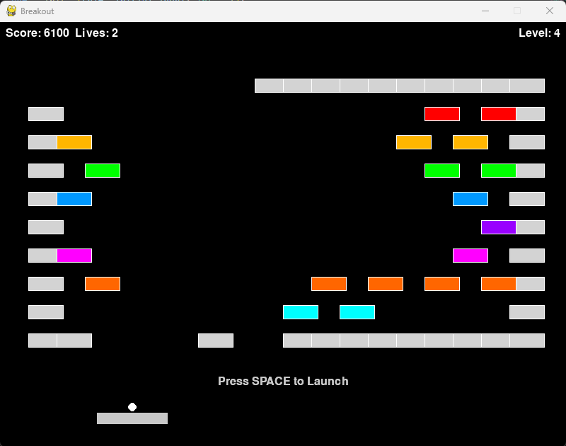
Level 4 after a void out, while waiting for the user to launch to ball
Input Manager
- Launching logic, pressing space launches an unlaunched ball, input is ignored if the ball is already moving and considered launched.
- Movement handling, when in the playing game state, left and right keys move the paddle. A fake input mapping is created to test unexpected key sequences.
- State transitions, handles menu navigation and global quit inputs.
Score Manager
- Level existence and loading, verifies that a level exists by attempting to load the first level and correct populates.
- Level navigation, exercises the next_level and get_available_levels functionality.
- Completion percentage, starts at 0% and changes appropriately as blocks are removed.
- All-levels loader, attempts to load all levels and verify that all of them work.
Results of Unit Tests
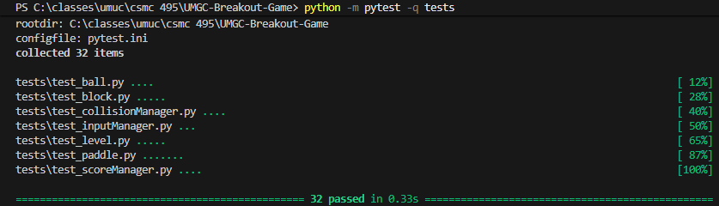

User Testing
- Pass Does Start Screen Appear
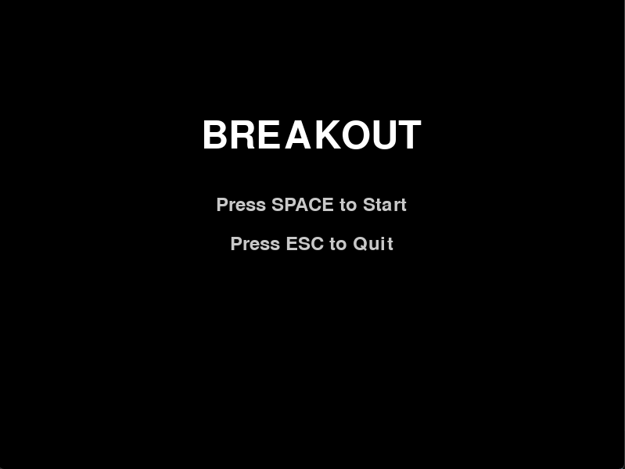
Figure 4A: Breakout main menu screen after running breakout.py
- Pass Does Select Screen Appear
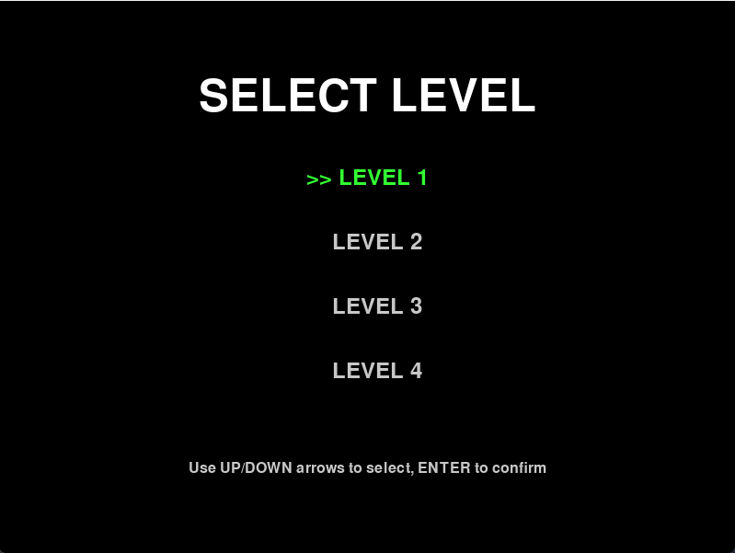
Figure 4B: Select Level Screen
- Pass Does Ball Launch and Control as Expected, and Scoring Works
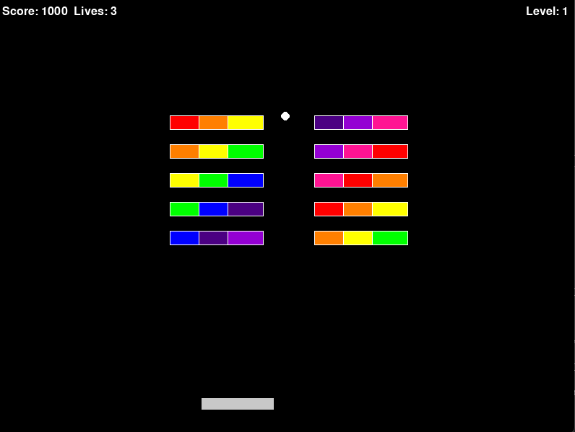
Figure 4C: Ball in action after starting the game
- Pass Does level completion work
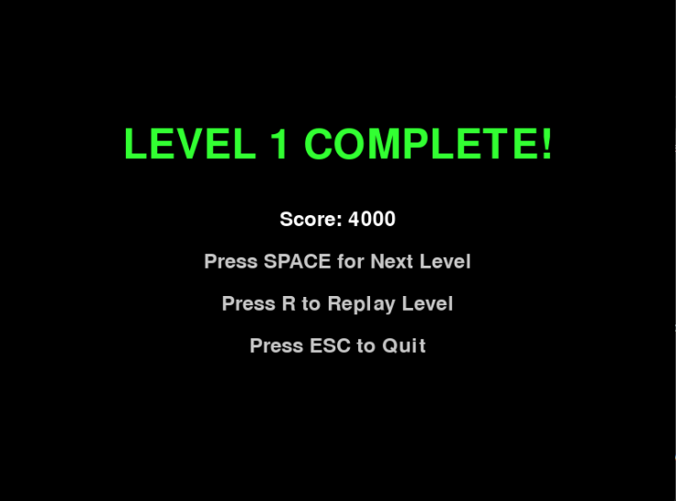
Figure 4D: Level completion screen when level is completed.
- Pass Does game end when lives go to zero
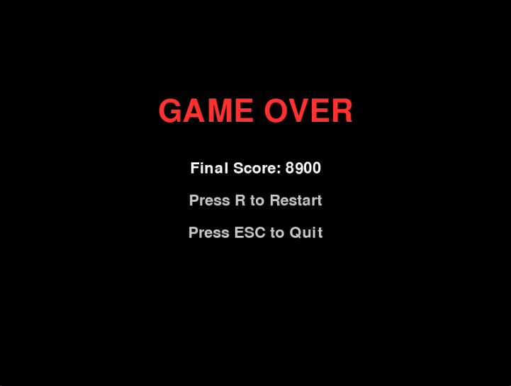
4E: Game over screen displays when all lives are lost

4.3 Validation
Validation was performed to confirm the Breakout game meets the MVP requirements and functions correctly from a user perspective. The team validated the complete gameplay flow, including launching the game, starting from the menu, selecting levels, launching the ball, controlling the paddle, scoring, life loss, and correct transitions to Level Complete and Game Over screens. Validation evidence includes recorded results from executing these scenarios and screenshots of key screens.
In addition, automated unit tests were run to verify correctness of core modules (Ball, Paddle, Block, Level loading, and related managers). The test suite was executed using python -m pytest -q tests, and all tests passed. Together, the end-to-end user validation and automated verification confirm the final build meets requirements and is stable for submission.

5 Design and Alternate Designs
Multiple architectural alternatives were evaluated before finalizing design decisions. Trade-offs were analyzed in terms of scalability, maintainability, and resource usage.
During testing, refinements were made:
- Adjusted paddle bounce physics for improved responsiveness.
- Refactored void detection to prevent duplicate life deductions.
- Strengthened JSON validation logic.
Each design change was documented and justified based on testing evidence rather than subjective preference.

6 Development History
The milestone table below defines our project timeline from initial planning through final submission. Included are internal build checkpoints (Alpha, Beta, and Submission-Ready) to ensure the game is playable early and continues to improve through testing and polish. The team used these milestones to stay organized and track progress, during the development the team managed to adhere to the timeline as specified. The team leveraged one week sprint cycles, from Friday to Friday.
Milestone | Start Date | End Date | Est. Effort (Team Hours) | Completion Criteria
Project Plan (Course) | Jan 19, 2026 | Jan 20, 2026 | 4–6 | Plan completed and agreed on by team
Project Design (Course) | Jan 21, 2026 | Jan 27, 2026 | 6–10 | Core gameplay + feature list finalized
Core Setup Complete | Jan 23, 2026 | Jan 31, 2026 | 12–18 | Pygame runs; paddle + ball move; basic collisions work
Alpha Build (Internal) | Jan 28, 2026 | Feb 2, 2026 | 18–30 | 1 playable level; blocks break; scoring + lives; win/lose works
Phase I Source (Course) | Feb 1, 2026 | Feb 3, 2026 | 3–5 | Phase I code submitted and runs correctly
Peer Review 1 (Course) | Feb 1, 2026 | Feb 3, 2026 | 1 | Submitted
Gameplay Complete | Feb 3, 2026 | Feb 9, 2026 | 12–20 | UI screens; physics stable; basic feedback added
Test Plan (Course) | Feb 6, 2026 | Feb 10, 2026 | 5–8 | Test cases written and organized
Beta Build (Internal) | Feb 10, 2026 | Feb 14, 2026 | 16–28 | Feature-complete; focus on bug fixing and polish
Phase II Source (Course) | Feb 14, 2026 | Feb 17, 2026 | 3–5 | Phase II code submitted: stable build
Polish + Optional Features | Feb 17, 2026 | Feb 21, 2026 | 10–18 | Improve feel, visuals/audio; add extras if time allows
User Guide (Course) | Feb 20, 2026 | Feb 24, 2026 | 4–6 | Instructions completed (setup + controls + gameplay)
Submission-Ready Build (Internal) | Feb 22, 2026 | Feb 28, 2026 | 10–18 | Final-ready build; only critical fixes left
Final Submission (Course) | Feb 28, 2026 | Mar 3, 2026 | 6–10 | Final build + materials submitted
Peer Review 2 (Course) | Mar 1, 2026 | Mar 3, 2026 | 1 | Submitted

7 Discussion
Architectural decisions significantly impact maintainability. Early incorporation of automated testing reduces debugging time later. Clear separation of responsibilities enhances efficiency but must be balanced with shared system knowledge. The project is built with a strong modular design, centralized collision management, scalable level configuration, and consistent testing discipline. The system does not include sound effects, persistent storage, or advanced graphical enhancements. Distribution requires Python and Pygame installation.

8 Conclusion
This project successfully fulfills all defined requirements and demonstrates disciplined software engineering practices. The team delivered a stable, scalable, and testable recreation of the Breakout arcade game within the constraints of the academic term.
Beyond functionality, the project highlights the importance of structured process, architectural foresight, systematic testing, and effective collaboration. The resulting system is not only playable but maintainable and extensible, meeting the highest standards outlined in the grading rubric.

9 References
- References

10 Appendix
- Appendix
  - System specification: technical specifications, minimum hardware requirements of the project implemented
  - User Guide
  - Other appendices (optional)

